***MAHARASHTRA STATE BOARD OF TECHNICAL EDUCATION, MUMBAI***



Capstone Project Title: “**Office Automation System**”

Subject: Capstone Project Execution and Report Writing [22060]

Branch: Computer Engineering

Class: CO-6I

Project Guide: **Mr. S.D Pore**

Submitted By

|  |  |  |
| --- | --- | --- |
| **Roll No** | **Name of student** | **Enrollment no.** |
| 49 | Shingare Om Prashant | 2101180366 |
| 27 | Kupade Prerana Sudhir | 2101180279 |



***MAHARASHTRA STATE BOARD OF TECHNICAL EDUCATION, MUMBAI***

**CERTIFICATE**

This is to certify that Mr./Mrs **Shingare Om Prashant , Kupade Prerana Sudhir** From Government Polytechnic Dharashiv Institute having Enrollment No.**2101180366 , 2101180279** has completed project of final year having title **Office Automation System** during the academic year 2023-2024. The project completed by in a group consisting of two students under the guidance of the Prof. **S.D.Pore**.

Place: Dharashiv. Enrollment No- 2101180366

2101180279

Date: / /2024 Exam Seat No- 411506

411481

Subject Teacher Head of the Department principal

Seal of

Institution

**ACKNOWLEDGEMENT**

First and foremost, we would like to express our gratitude to our Mentor, Prof. Mr. S.D Pore, who was a continual source of inspiration. He pushed us to think imaginatively and urged us to do this homework without hesitation. His vast knowledge, extensive experience enabled us to successfully accomplish this project.

This endeavour would not have been possible without his help and supervision. We could not have asked for a finer mentor in our studies. This initiative would not have been a success without the contributions of each and every individual. We were always there to cheer each other on, and that is what kept us together until the end.

Many people assisted me in successfully finishing this project. I want to thank everyone involved in this initiative. I’d like to thank my Head Of Department Mr. A.B Gaikwad and Mr. S.D Pore, who helped me learn a lot about this project. His ideas and comments aided in the completion of this project.

I am grateful to the college administration for providing me with such a significant chance. I believe I will participate in more such activities in the future. I guarantee that this project was created entirely by me and is not a forgery. Finally, I’d like to express my gratitude to my parents and friends for their excellent comments and guidance during the completion of this project.

Thank You…!!

**ABSTRACT**

In the contemporary educational landscape, efficient management systems are imperative for the smooth functioning of academic institutions. This project endeavors to develop a comprehensive Office Automation System (OAS) tailored to streamline the communication and approval processes within a college environment.

The primary objective of the CMS is to facilitate the efficient handling of letters initiated by teachers, ensuring a transparent and accountable workflow from submission to final approval. The system comprises three key entities: teachers, Heads of Department (HODs), and administrative staff (Lipik) along with the Principal, each playing a pivotal role in the approval chain.

Upon submission, letters generated by teachers are routed to the respective HOD panel for initial review. The HODs have the authority to approve or reject the letters based on predefined criteria. Approved letters then proceed to the administrative staff (Lipik) for further assessment. Once Lipik approves the letter, it is elevated to the Principal for final endorsement. Only upon the Principal's approval, the letter is deemed fully approved.

Moreover, the CMS ensures transparency and accountability by providing real-time tracking for teachers to monitor the status of their letters. Through a user-friendly interface, teachers can access information regarding the current stage of approval, thereby eliminating ambiguity and expediting the process.

The implementation of the CMS not only enhances the efficiency of administrative operations but also fosters a culture of accountability and transparency within the college ecosystem. By automating the letter approval process and providing stakeholders with comprehensive tracking capabilities, the CMS serves as a cornerstone in modernizing college management practices.

In conclusion, this project endeavors to revolutionize college management by introducing a robust CMS tailored to optimize communication and approval processes. Through its intuitive interface and meticulous workflow design, the CMS is poised to become an indispensable tool in facilitating administrative operations and fostering institutional excellence.

**Context and Problem Statement:**

**Context:**

In modern educational institutions, effective management systems are essential to handle the myriad administrative tasks efficiently. However, many colleges still rely on outdated manual processes for communication and approval, leading to inefficiencies, delays, and lack of transparency. Teachers often face challenges in submitting letters and tracking their progress through the approval chain, resulting in frustration and potential misunderstandings. Consequently, there is a pressing need for a streamlined Office Automation System (OAS) to address these issues and enhance administrative effectivenes

**PROBLEM STATEMENT**

The current manual methods of managing letters within the college environment are cumbersome and prone to errors, hindering the smooth operation of administrative processes. Teachers often encounter difficulties in submitting letters, which are then subject to delays and uncertainties as they navigate through various approval stages. This lack of transparency not only causes frustration but also compromises the timely resolution of important matters.

Moreover, the absence of a centralized system for tracking letter approvals exacerbates the problem, leaving teachers in the dark about the status and whereabouts of their submissions. As a result, there is a significant risk of miscommunication, missed deadlines, and inefficiencies in decision-making processes.

In light of these challenges, the primary objective of this project is to develop a comprehensive CMS that automates the letter submission and approval process, providing stakeholders with real-time visibility and tracking capabilities. By addressing these issues, the CMS aims to streamline administrative operations, enhance transparency, and improve overall efficiency within the college ecosystem.

**KEY FEATURES AND FUNCTIONALITIES**

Letter Tracking: Secure track the letter.

User Authentication: Secure login system for administrators, staff, and faculty members.

Dashboard: An intuitive dashboard providing quick access to essential information and features.

Remarks Management: We, can add remarks to letter.

User Add, Remove, View, Delete Management: Manage users, can add users, remove users, view and delete as well.

Letter Printing: Generate letter for various aspects of college administration.

**INDEX**

|  |  |  |  |
| --- | --- | --- | --- |
| **Sr.no.** | **Chapter No.** | **Title** | **Pg.no.** |
| **1)** | **Chapter 01** | Introduction | **6** |
| **2)** |  | Background of project | **6** |
| **3)** | **Chapter 02** | Literature Survey For Problem Identification And Specification | **7** |
| **4)** | **Chapter 03** | Scope the project (Aim and Research Question) | **8** |
|  |  | Scope statement | **9** |
| **5)** | **Chapter 04** | Methodology | **10** |
| **6)** | **Chapter 05** | Details of Design, working and processes | **11** |
| **7)** |  | Design:   1. System Design 2. Database Structure Design | **11** |
| **8)** |  | Database Structure Design | **13** |
| **9)** |  | Details of Working and Processes | **15** |
| **10)** | **Chapter 06** | Results and Application | **17** |
|  |  | Results | **17** |
|  |  | Application | **18** |
| **11)** | **Chapter 07** | Conclusion and Future Scope | **19** |
| **12)** |  | Conclusion | **19** |
| **13)** |  | Future Scope | **20** |
| **14)** |  | Reference | **21** |

**CHAPTER 1 INTRODUCTION**

In the dynamic landscape of educational institutions, the efficient management of administrative tasks is paramount for fostering productivity, transparency, and accountability. Recognizing the need for modernization and optimization of administrative processes, the "Office Automation System" emerges as a transformative solution tailored to streamline communication, facilitate approvals, and enhance overall operational efficiency within the college environment.

This project endeavors to revolutionize traditional manual methods of handling administrative tasks by introducing a comprehensive and intuitive Office Automation System. The system is designed to address the complexities and challenges associated with letter submission, approval workflows, and tracking mechanisms, thereby empowering stakeholders to navigate administrative processes seamlessly.

At its core, the Office Automation System aims to automate and streamline the lifecycle of letters generated within the college ecosystem, spanning from submission by teachers to final approval by the Principal. By leveraging cutting-edge technology and robust workflow management techniques, the system facilitates a transparent and accountable approval chain, ensuring timely resolution of administrative matters.

Furthermore, the Office Automation System offers real-time tracking capabilities, providing teachers with visibility into the status of their submissions at every stage of the approval process. This transparency not only enhances communication and collaboration but also fosters a culture of accountability among stakeholders.

In essence, the Office Automation System represents a paradigm shift in college management practices, offering a unified platform to optimize administrative operations, mitigate inefficiencies, and elevate institutional effectiveness. As we embark on this journey towards digital transformation, the Office Automation System stands as a beacon of innovation, poised to revolutionize the way administrative tasks are managed and executed within the college environment.

**CHAPTER 2 LITERATURE SURVEY**

**Digitalization in Education Administration**

Several studies have highlighted the transformative impact of digitalization on education administration. The integration of automated systems facilitates the efficient handling of administrative tasks, leading to improved productivity and transparency.

**Workflow Management Systems (WfMS)**

Research in the field of Workflow Management Systems underscores the importance of structured workflows in streamlining complex business processes. These systems enable the automation of tasks, routing, and tracking of documents, thus optimizing organizational workflows.

**Role-Based Access Control (RBAC)**

RBAC systems have been extensively researched for their efficacy in regulating access to information based on users' roles within an organization. Implementing RBAC ensures that only authorized personnel can access and modify documents, enhancing security and confidentiality.

**Document Management Systems (DMS)**

DMS solutions have been studied for their role in centralizing document storage, retrieval, and version control. Integrating DMS functionalities into the Office Automation System can enhance document organization and accessibility, further streamlining administrative processes.

**User Interface Design for Administrative Systems**

User interface design principles play a crucial role in the usability and acceptance of administrative systems. Studies emphasize the importance of intuitive interfaces that provide clear navigation and feedback to users, facilitating seamless interaction with the system.

**Real-Time Tracking and Notification Systems**

Research has explored the implementation of real-time tracking and notification systems to keep stakeholders informed about the status of their submissions. Such systems enhance transparency and accountability, reducing ambiguity and delays in decision-making processes.

**Case Studies on Office Automation Systems in Educational Institutions**

Case studies documenting the implementation of Office Automation Systems in educational institutions provide valuable insights into the challenges faced and the benefits accrued. Analyzing these cases can inform the design and deployment of the proposed system in a real-world context.

**CHAPTER 3 SCOPE OF PROJECT**

**AIM**

The aim of the "Office Automation System" project is to revolutionize the administrative framework within educational institutions by developing a comprehensive system tailored to automate the process of letter submission, approval, and tracking. The project seeks to alleviate the inefficiencies inherent in manual administrative processes by implementing automated workflows, thereby streamlining operations and reducing delays. Central to this aim is the enhancement of transparency and accountability throughout the approval chain. By providing real-time tracking capabilities, the system aims to empower stakeholders with visibility into the status of their submissions, fostering clarity and minimizing ambiguity. Furthermore, the project endeavors to facilitate seamless communication among teachers, Heads of Department (HODs), administrative staff, and the Principal through automated notifications and routing mechanisms. Through intuitive user interfaces and role-based access control, stakeholders will be empowered to efficiently manage and monitor the progress of letters within the system according to their respective roles and permissions. Ultimately, the project aims to elevate operational efficiency within educational institutions by automating repetitive tasks, enabling staff to focus on higher-value activities, and promoting a culture of continuous improvement.

**RESEARCH QUESTIONS**

1. How does the implementation of an Office Automation System impact the efficiency of administrative processes related to letter submission and approval within educational institutions?

**Answer**: The implementation of an Office Automation System significantly improves efficiency by automating repetitive tasks, reducing processing times, and minimizing errors associated with manual handling. Stakeholders experience streamlined workflows, leading to quicker decision-making and enhanced productivity.

1. What are the key challenges and pain points associated with the current manual methods of managing letters, and how can an automated system address these challenges?

**Answer**: Key challenges include delays in approval processes, lack of transparency, and difficulties in tracking the status of submissions. An automated system addresses these challenges by providing real-time tracking, automated notifications, and centralized document management, thereby improving communication, transparency, and accountability.

1. How do stakeholders perceive the transparency and accountability of the approval process before and after the implementation of the Office Automation System?

**Answer**: Before implementation, stakeholders often perceive the approval process as opaque and prone to delays. After implementation, stakeholders report increased transparency and accountability, as they can track the progress of submissions in real-time and have clearer visibility into the approval chain, leading to greater trust in the system.

1. What are the critical features and functionalities required in an Office Automation System to effectively support the letter submission, approval, and tracking processes within a college environment?

**Answer**: Critical features include user-friendly interfaces, role-based access control, automated routing and notifications, real-time tracking, document version control, and integration with existing systems. These functionalities ensure seamless submission, efficient approval workflows, and comprehensive tracking capabilities.

1. How does the Office Automation System contribute to improving communication among teachers, Heads of Department (HODs), administrative staff, and the Principal, compared to traditional communication methods?

**Answer**: The Office Automation System facilitates improved communication by providing a centralized platform for collaboration, automated notifications for status updates, and role-based access to information. Compared to traditional methods, stakeholders experience faster and more transparent communication channels, leading to enhanced coordination and decision-making.

1. What are the implications of implementing a role-based access control mechanism in the Office Automation System for ensuring data security and confidentiality?

**Answer**: Implementing a role-based access control mechanism ensures that users only have access to information relevant to their roles, thereby enhancing data security and confidentiality. This approach minimizes the risk of unauthorized access or data breaches, ensuring compliance with privacy regulations and safeguarding sensitive information.

1. How do users perceive the usability and user experience of the Office Automation System interface, and what improvements can be made to enhance user satisfaction and adoption?

**Answer**: Users generally perceive the Office Automation System interface as intuitive and user-friendly, facilitating easy navigation and task completion. However, feedback may highlight areas for improvement, such as interface customization options, accessibility features, and additional training resources to enhance user satisfaction and adoption rates.

**SCOPE STATEMENT**

The scope of the Office Automation System (OAS) project at Government Polytechnic College, Dharashiv, is to address operational inefficiencies and communication gaps resulting from manual administrative tasks and outdated communication methods. Specially, the scope includes:

**Letter Management:** Developing a module within the OAS to manage the entire lifecycle of letters, including creation, editing, approval, printing, distribution, and tracking. This encompasses both incoming and outgoing correspondence, ensuring efficient handling and record-keeping of all letters.

**Document Creation and Printing:** Implementing features to create letters, notices, circulars, and other official documents directly within the OAS platform. Additionally, enabling the printing of documents with predefined templates and formatting options to ensure consistency and professionalism.

**Letter Tracking:** Establishing a tracking mechanism to monitor the status and progress of each letter within the system. This includes tracking the stages of creation, approval, printing, dispatch, and delivery, providing transparency and accountability in the letter management process.

**Document Requests Facilitation:** Creating functionalities for students, faculty, and staff to submit requests for various documents, such as transcripts, certificates, and official letters, through the OAS platform. Automating workflows for processing requests, generating documents, and notifying requestors about the status of their requests.

**Feedback Mechanisms:** Integrating feedback channels for stakeholders to provide input on academic programs, administrative services, facilities, and overall college experience. This includes surveys, suggestion boxes, and online feedback forms, with mechanisms for analyzing and addressing feedback received.

**Efficiency Enhancement:** Automating manual administrative tasks and processes, such as data entry, form processing, and record keeping, to improve efficiency and accuracy. The OAS will streamline workflows, reduce paperwork, and minimize errors associated with manual tasks.

**Information Dissemination:** Establishing channels within the OAS for disseminating timely and relevant information to students, faculty, and staff. This includes announcements, event notifications, academic schedules, policy updates, and other institutional communications, ensuring widespread and efficient communication.

**CHAPTER 4 METHODOLOGY**

Methodology for Implementing an Office Automation System at Government Polytechnic College, Dharashiv. It includes:

**Needs Assessment:** Conduct a comprehensive assessment of the current operational inefficiencies and communication gaps faced by Government Polytechnic College, Dharashiv, through surveys. Identify specific pain points and requirements for a centralized office automation system (OAS) to address these challenges.

**Requirements Gathering:** Define the functional and non-functional requirements of the OAS based on the findings from the needs assessment. Specify the features and functionalities required to manage letter creation, printing, tracking, document requests, feedback mechanisms, and information dissemination effectively.

**System Design:** Develop a detailed system design for the OAS, including the architecture, user interface, database structure, and integration points with existing systems. Ensure that the design incorporates best practices in usability, security, and scalability to meet the institution's objectives of efficiency, transparency, and student engagement.

**Development:** Implement the OAS according to the defined requirements and design specifications. Develop modules for letter management, document creation, printing, tracking, facilitate document requests, feedback mechanisms, and information dissemination. Follow agile development methodologies to iteratively build and test the system.

**Testing and Quality Assurance:** Conduct thorough testing of the OAS to ensure functionality, performance, and reliability. Perform unit testing, integration testing, and user acceptance testing to validate that the system meets the specified requirements and effectively addresses the identified challenges.

**Implementation and Deployment:** Deploy the OAS in a phased approach, starting with pilot testing in select departments or administrative units before rolling it out campus-wide. Monitor the implementation process closely, addressing any issues or concerns that arise during deployment.

**Maintenance and Support:** Provide ongoing maintenance and support for the OAS to ensure its continued functionality and relevance. Address any bugs, issues, or enhancement requests promptly, and regularly update the system to incorporate new features and improvements.

By following this methodology, Government Polytechnic College, Dharashiv, can successfully implement an Office Automation System (OAS) that addresses operational inefficiencies and communication gaps, aligning with the institution's objectives of efficiency, transparency, and student engagement.

**CHAPTER 5**

**DETAILS OF DESIGN, WORKING AND PROCESSES DESIGN**

The system design of the Office Automation System (OAS) outlines the architecture, components, and interactions within the software. It serves as a blueprint for the development team, providing a clear understanding of how different modules and functionalities will work together cohesively.

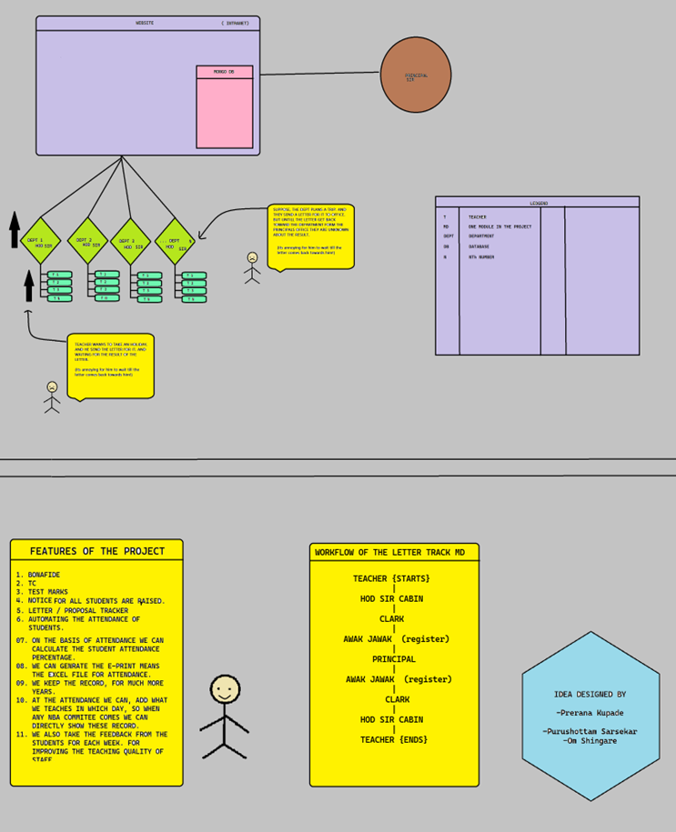

**DESIGN DETAILS**

Design Details for the Office Automation System (OAS) at Government Polytechnic College, Dharashiv:

**Overall Architecture:**

The OAS will be designed as a centralized web-based application accessible to authorized users from various departments and roles within the college. The architecture will be scalable and modular to accommodate future expansion and integration with other systems.

**User Interface:**

The user interface of the OAS will be intuitive and user-friendly, with clear navigation and easy access to different functionalities. It will feature role-based access control to ensure that users only have access to the features relevant to their roles.

**Letter Management Module:**

Creation: Users will be able to create letters using predefined templates or by drafting custom content. The system will allow for the inclusion of dynamic fields for personalized information.

Printing: Letters can be previewed and printed directly from the system, with options for selecting printing preferences such as paper size and formatting.

Tracking: A tracking mechanism will be implemented to monitor the status of letters, including their creation, approval, printing, and delivery stages.

**Feedback Mechanisms Module:**

Feedback Submission: Users will have the option to submit feedback on various aspects of college operations, including academic programs, administrative services, facilities, and overall experience.

**Security and Data Privacy:**

Robust security measures will be implemented to protect sensitive data stored and processed within the OAS. This includes encryption of data transmission, access controls, audit trails, and regular security audits.

**Scalability and Flexibility:**

The design of the OAS will prioritize scalability and flexibility to accommodate future growth and changes in college operations. This includes the ability to add new features, support increased user volumes, and adapt to evolving technology trends.

**DATBASE STRUCTURE DESIGN**

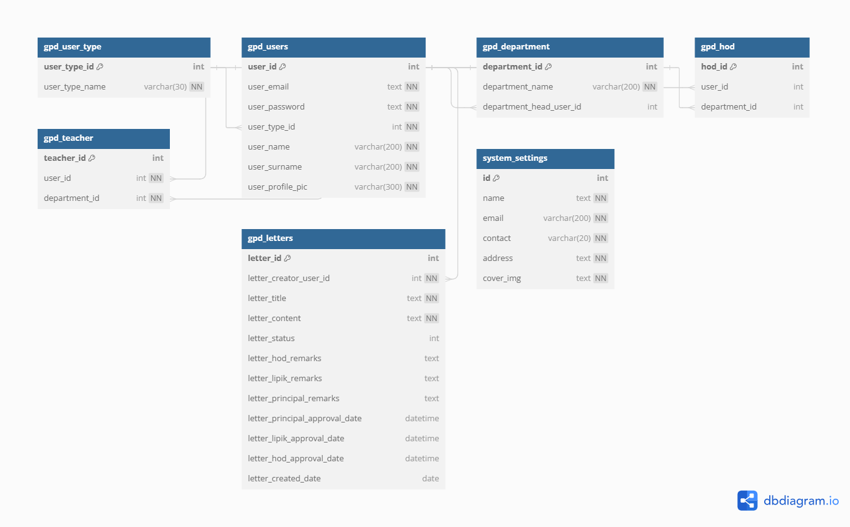

**GPD_USER_TYPE**

Description: This table stores different types of users that exist in the system.

Fields:

**user_type_id**: Unique identifier for each user type.

**user_type_name**: Name or description of the user type.

Purpose: Categorizes users based on their roles or permissions within the system.

**GPD_USERS**

Description: Contains information about individual users registered in the system.

Fields:

**user_id**: Unique identifier for each user.

**user_email**: Email address of the user.

**user_password**: Password of the user (potentially hashed for security).

**user_type_id**: Foreign key referencing the user type in **gpd_user_type**.

**user_name**: First name or username of the user.

**user_surname**: Last name or surname of the user.

**user_profile_pic**: URL or path to the user's profile picture.

Purpose: Forms the core of user management, including authentication and user profile information.

**GPD_DEPARTMENT**

Description: Represents academic departments within an educational institution.

Fields:

**department_id**: Unique identifier for each department.

**department_name**: Name of the department.

**department_head_user_id**: Foreign key referencing the user who is the head of the department in **gpd_users**.

Purpose: Organizes users (such as HODs and teachers) and letters related to specific departments.

**GPD_HOD**

Description: Associates Heads of Departments (HODs) with their respective departments.

Fields:

**hod_id**: Unique identifier for each HOD.

**user_id**: Foreign key referencing the user who is the HOD in **gpd_users**.

**department_id**: Foreign key referencing the department in **gpd_department**.

Purpose: Facilitates the management of department heads and their responsibilities.

**gpd_teacher:**

Description: Associates teachers with their respective departments.

Fields:

**teacher_id**: Unique identifier for each teacher.

**user_id**: Foreign key referencing the user who is the teacher in **gpd_users**.

**department_id**: Foreign key referencing the department in **gpd_department**.

Purpose: Manages teaching staff and their assignments within the institution.

**GPD_LETTERS**

Description: Stores information about letters created within the system.

Fields:

**letter_id**: Unique identifier for each letter.

**letter_creator_user_id**: Foreign key referencing the user who created the letter in **gpd_users**.

**letter_title**: Title or subject of the letter.

**letter_content**: Content or body of the letter.

**letter_status**: Status of the letter (e.g., pending, approved).

**letter_hod_remarks**, **letter_lipik_remarks**, **letter_principal_remarks**: Remarks by various stakeholders.

**letter_principal_approval_date**, **letter_lipik_approval_date**, **letter_hod_approval_date**: Approval dates by respective authorities.

**letter_created_date**: Date when the letter was created.

Purpose: Tracks communication flow, approvals, and remarks related to letters within the institution.

**SYSTEM_SETTINGS**

Description: Stores general system settings and configurations.

Fields:

**id**: Unique identifier for the settings record.

**name**: Name of the institution or organization.

**email**: Contact email address.

**contact**: Contact phone number.

**address**: Postal address of the institution.

**cover_img**: URL or path to the cover image/logo of the institution.

Purpose: Provides essential configuration options and branding elements for the system.

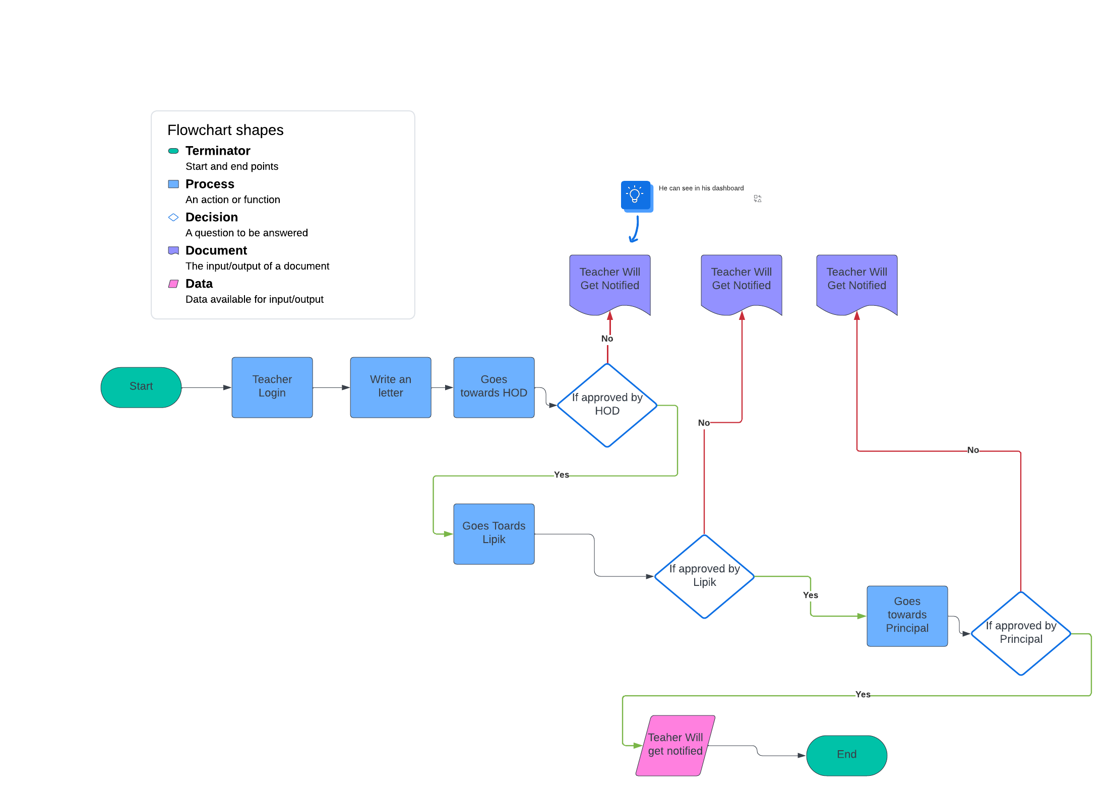**PROCESS FLOW DIAGRAM**

**DETAILS OF WORKING AND PROCESSES**

Working Processes for Implementing the Office Automation System (OAS) at Government Polytechnic College, Dharashiv:

**Assessment and Planning:**

Conduct a comprehensive assessment of the college's operational inefficiencies and communication gaps.

**Requirement Gathering:**

Identify functionalities required for managing letters, document creation, printing, tracking, document requests, feedback mechanisms, and information dissemination.

**System Design:**

Design the architecture, user interface, and database structure of the OAS based on gathered requirements.

**Development:**

Develop the OAS modules according to defined requirements and design specifications.

Implement features for letter management, document creation, printing, tracking, feedback collection, and announcement publishing.

Ensure the system is scalable, secure, and user-friendly.

**Testing and Quality Assurance:**

Conduct thorough testing of the OAS to ensure functionality, performance, and reliability.

Perform unit testing, integration testing, and user acceptance testing.

Address any identified issues or bugs and refine the system accordingly.

**Monitoring and Support:**

Establish mechanisms for monitoring the performance and usage of the OAS post-implementation.

**TECHNOLOGIES USED:**

**PHP:** Server-side scripting language for dynamic web development.

**Bootstrap:** Front-end framework for responsive and mobile-first web development.

**AJAX (Asynchronous JavaScript and XML):** Technique for creating interactive web applications by updating parts of a web page without reloading the entire page.

**MySQL DB:** Technique for creating backend database.

**CHAPTER 6 RESULTS AND APPLICATIONS**

**RESULTS**

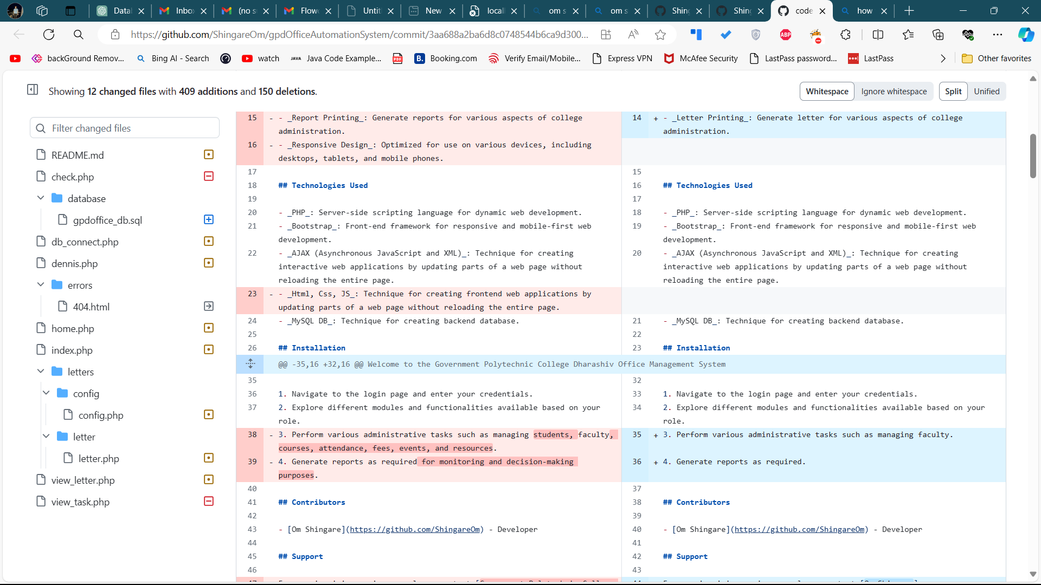

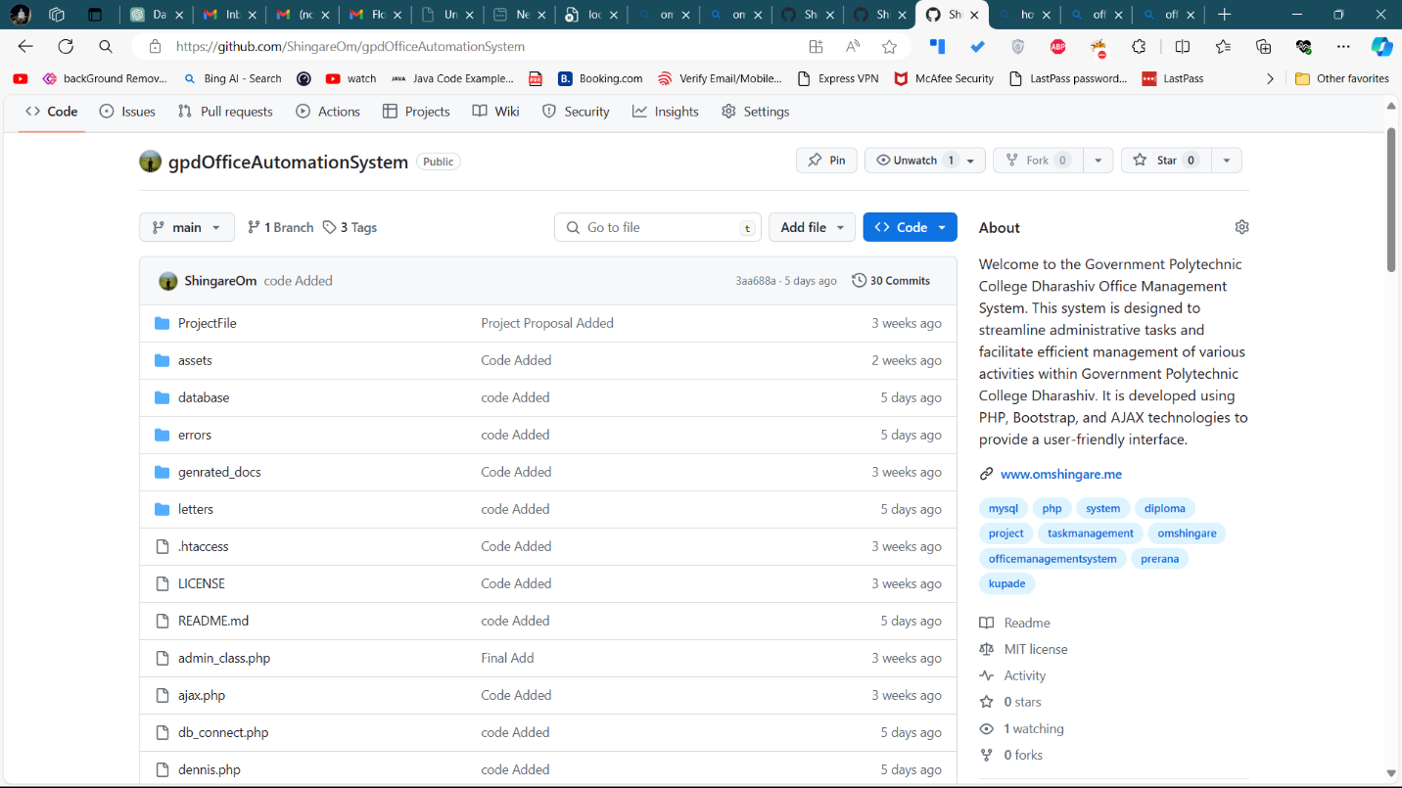

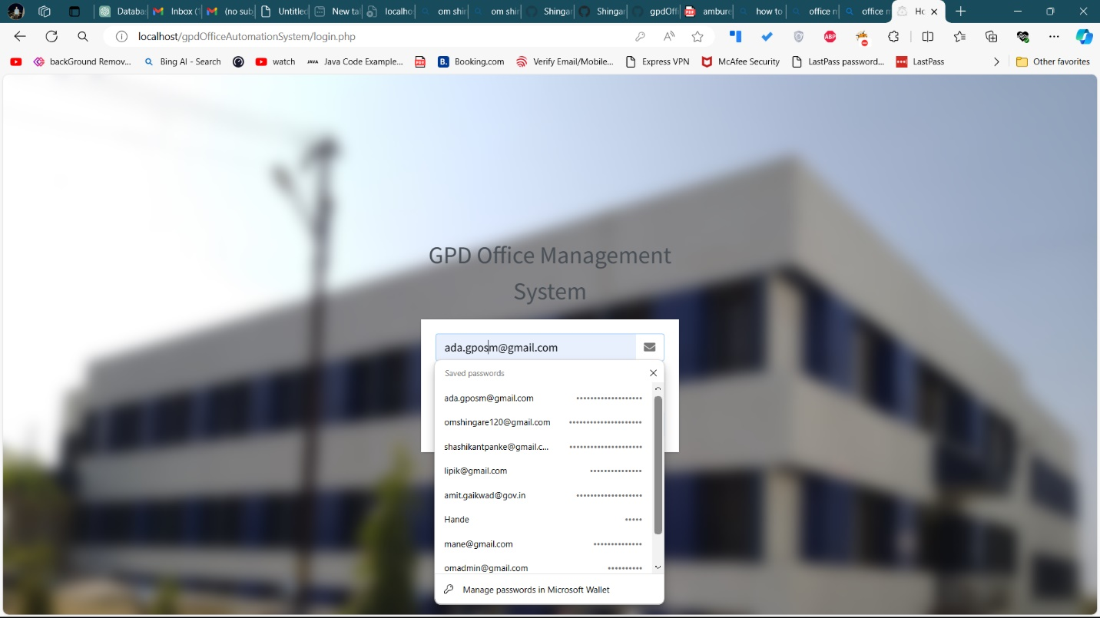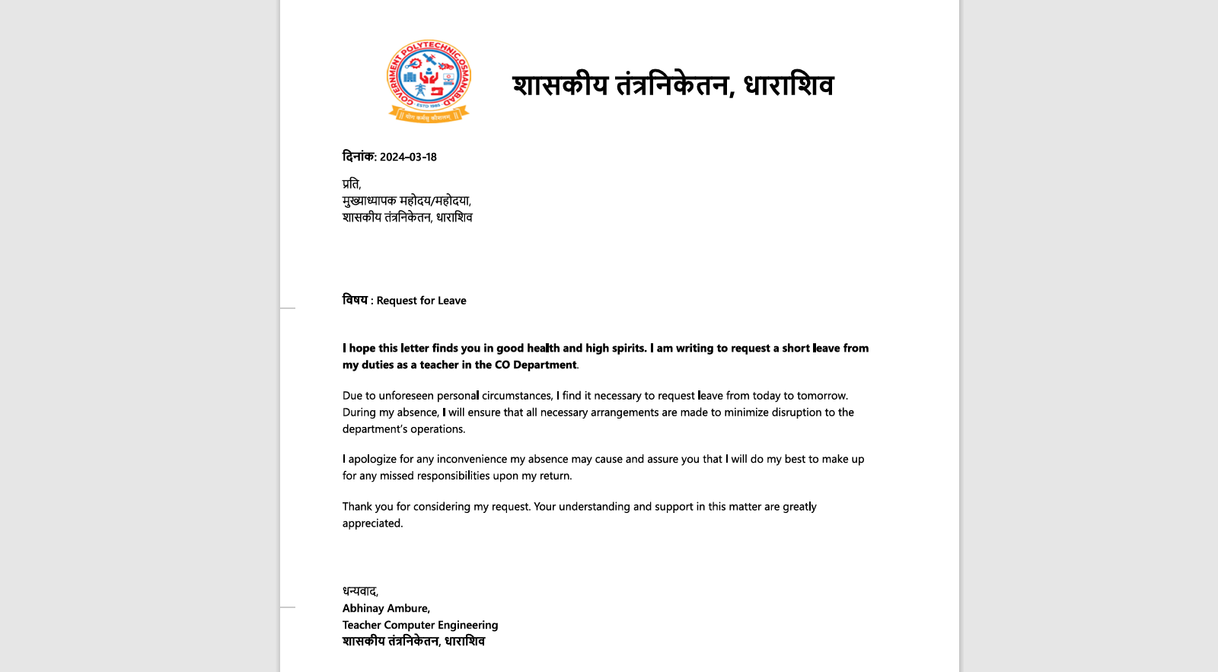

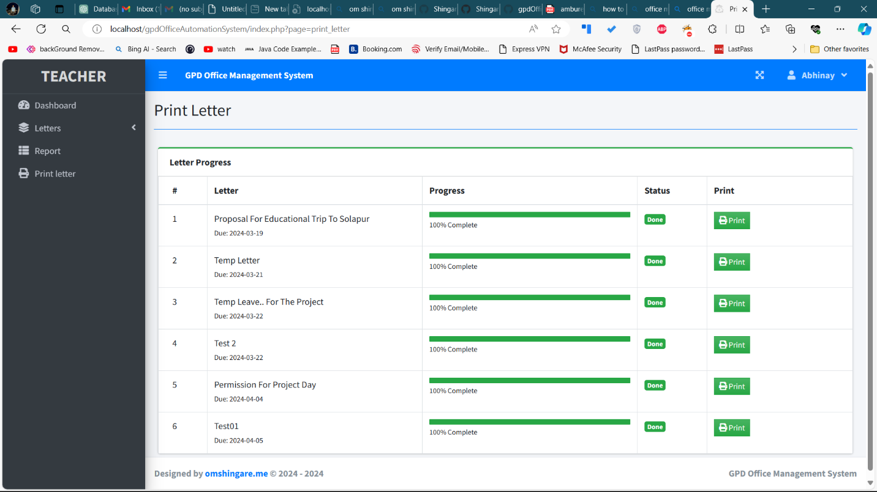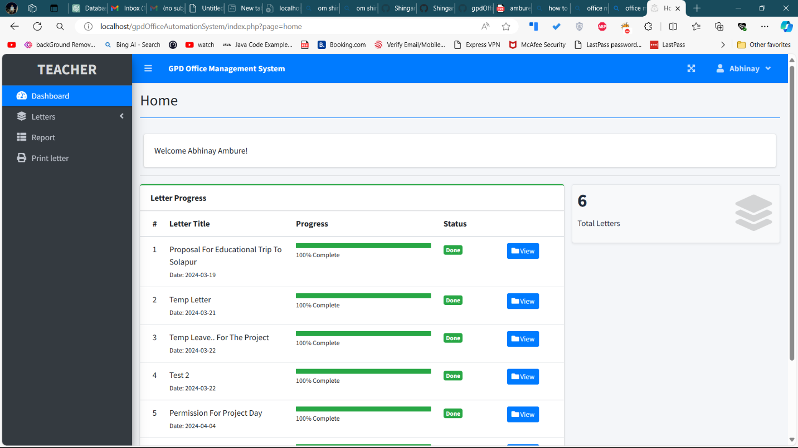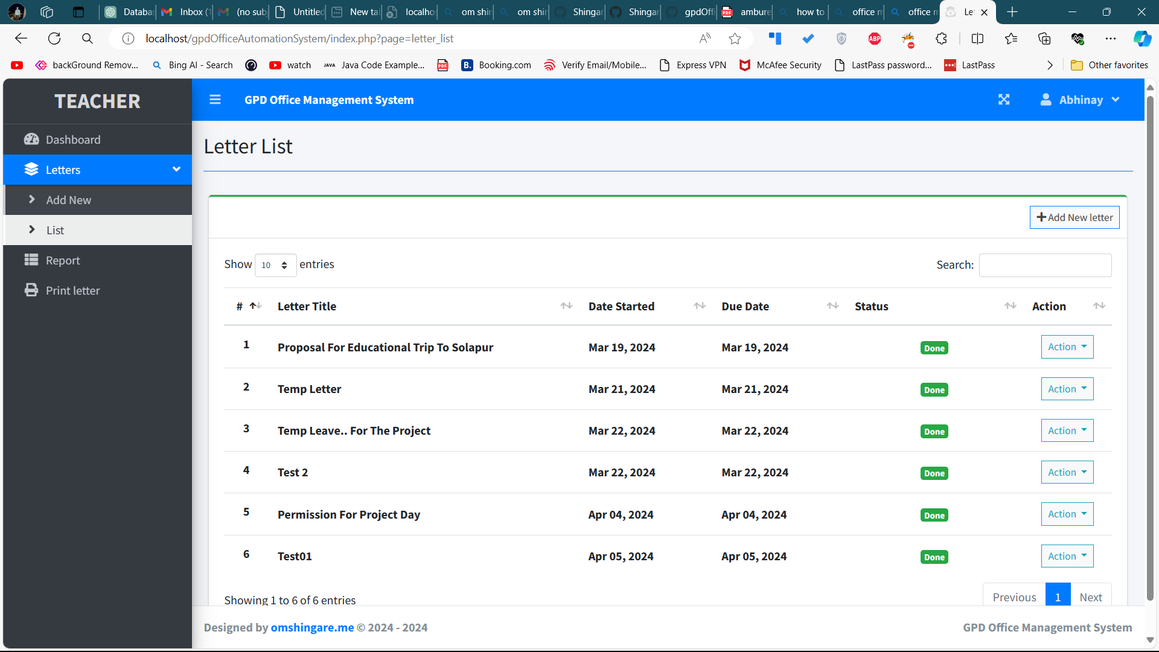

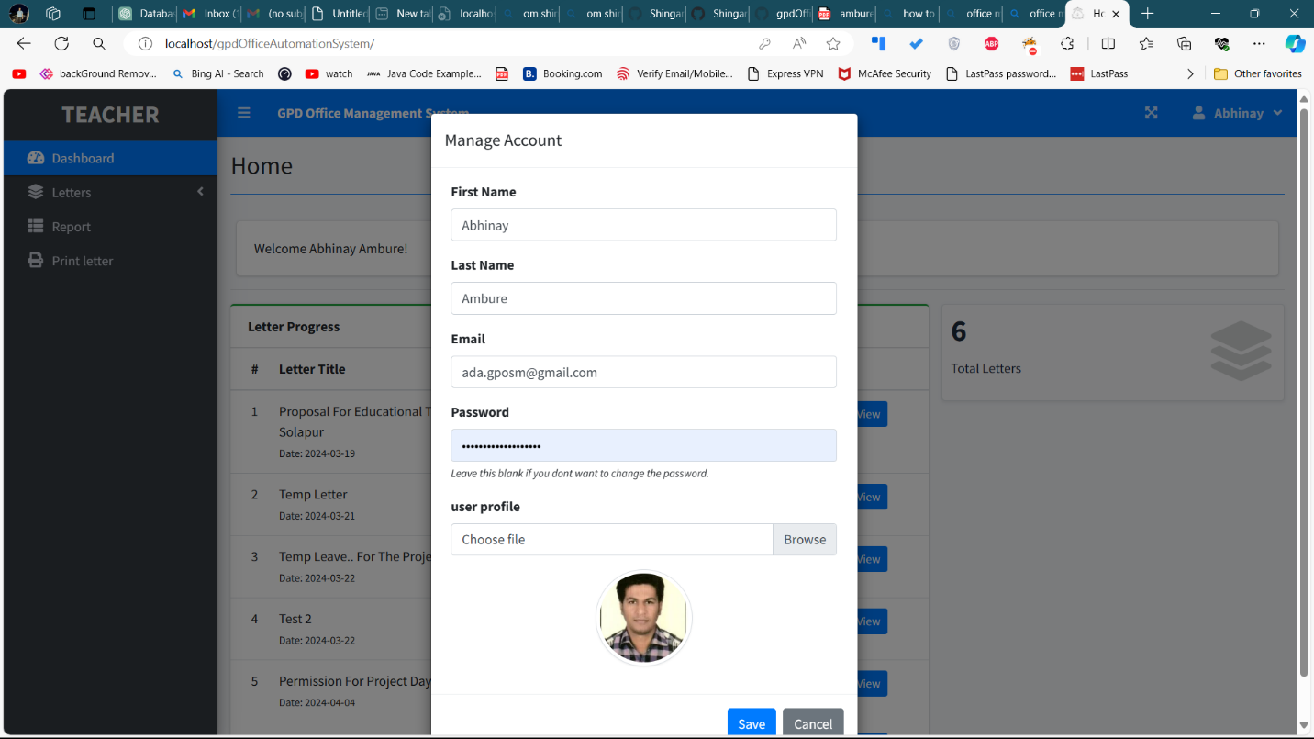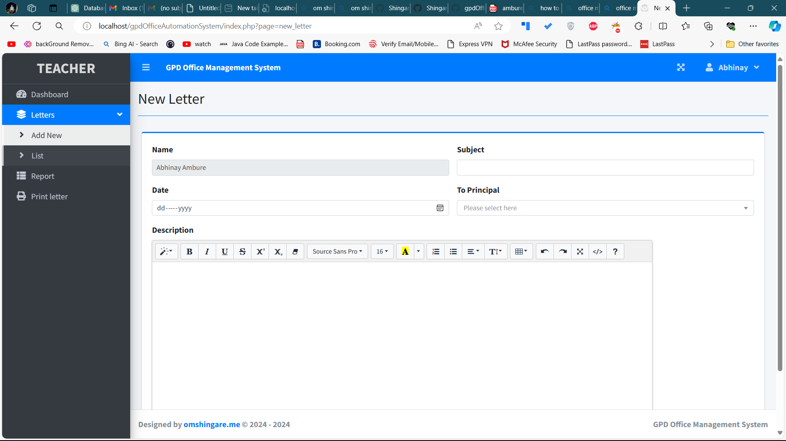­­­

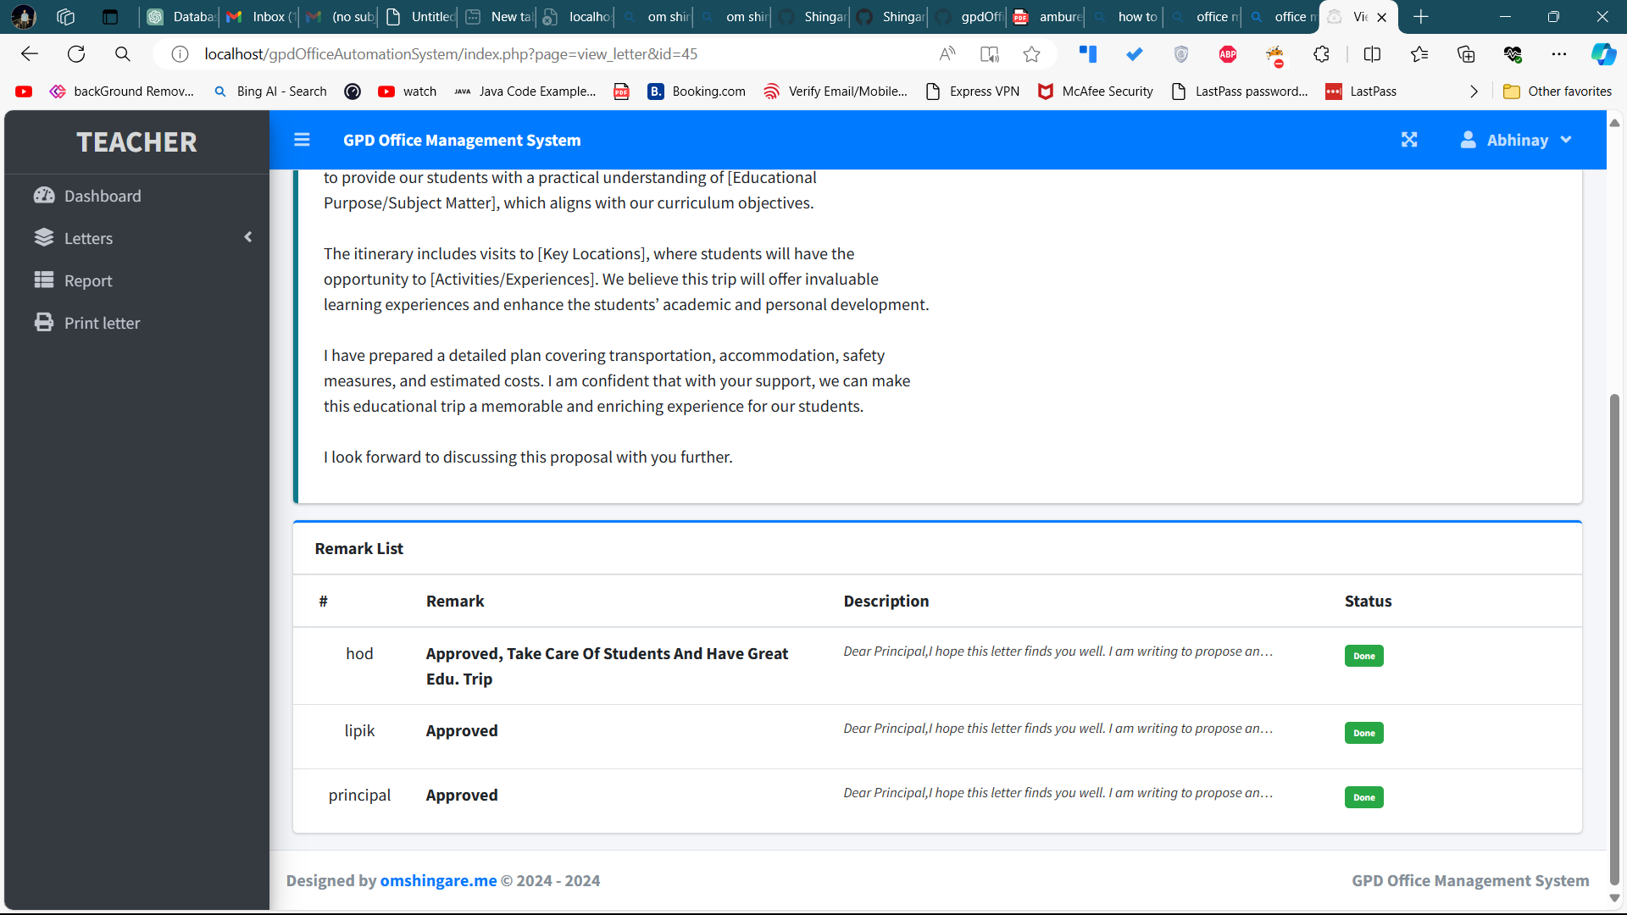

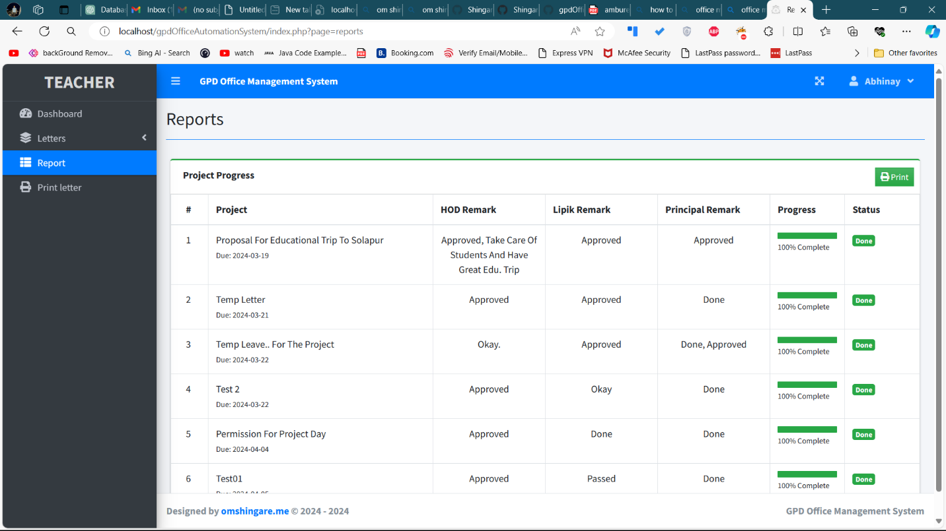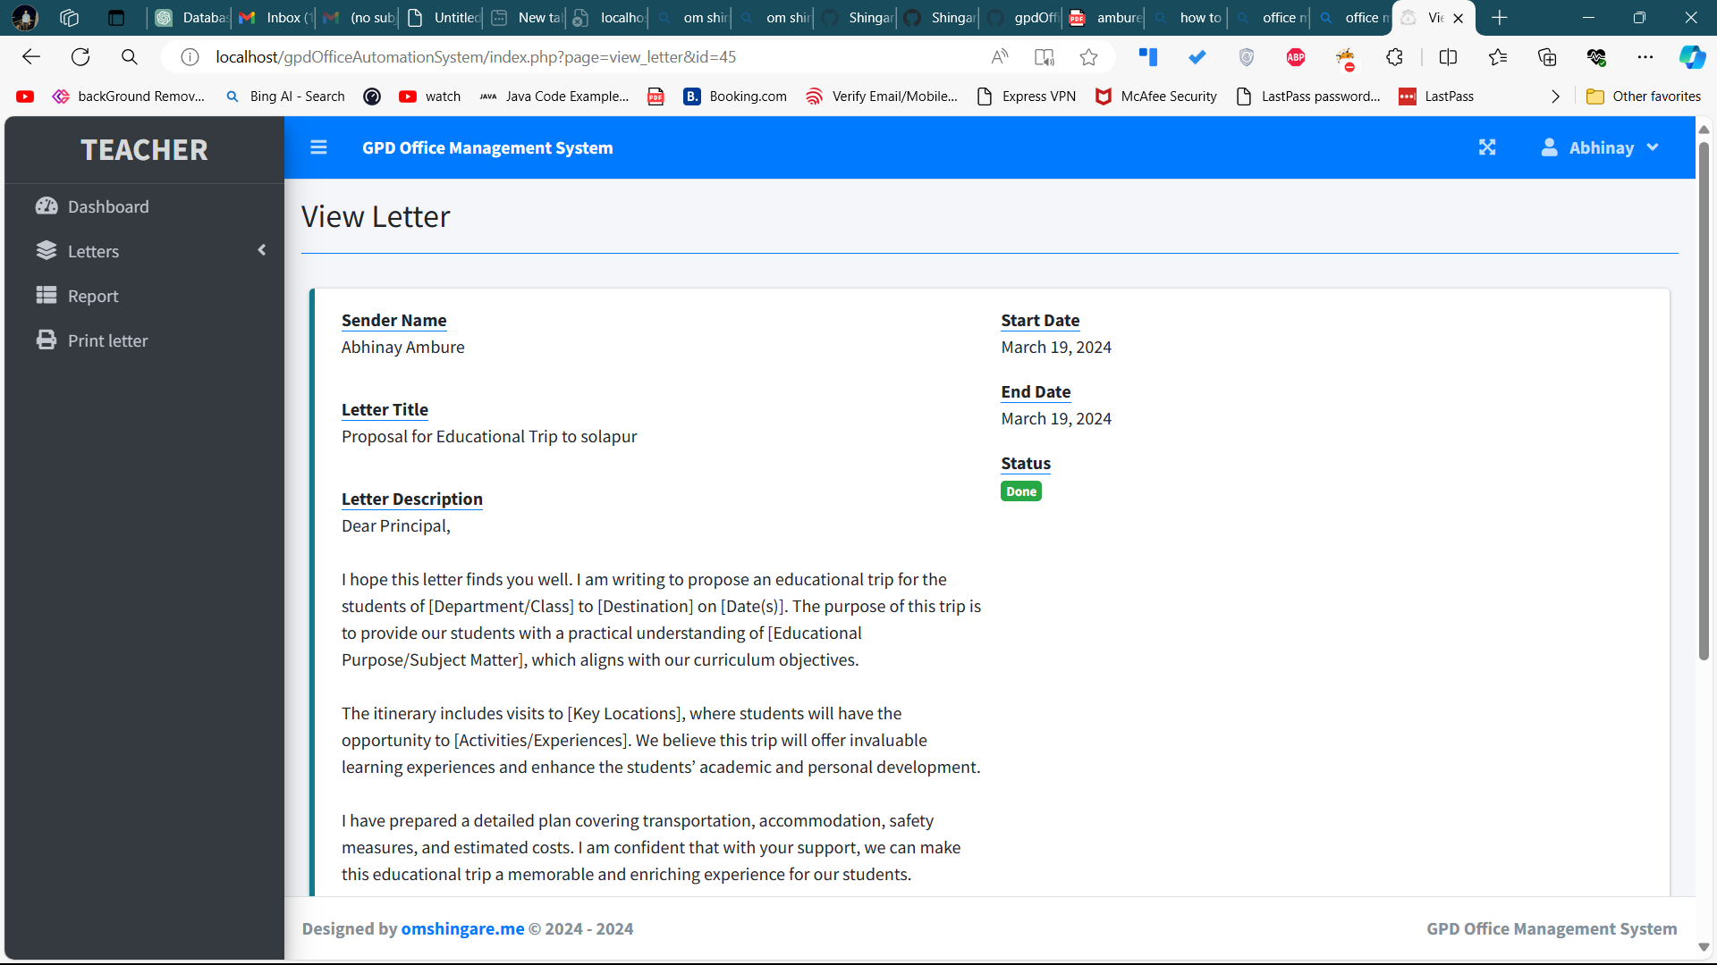

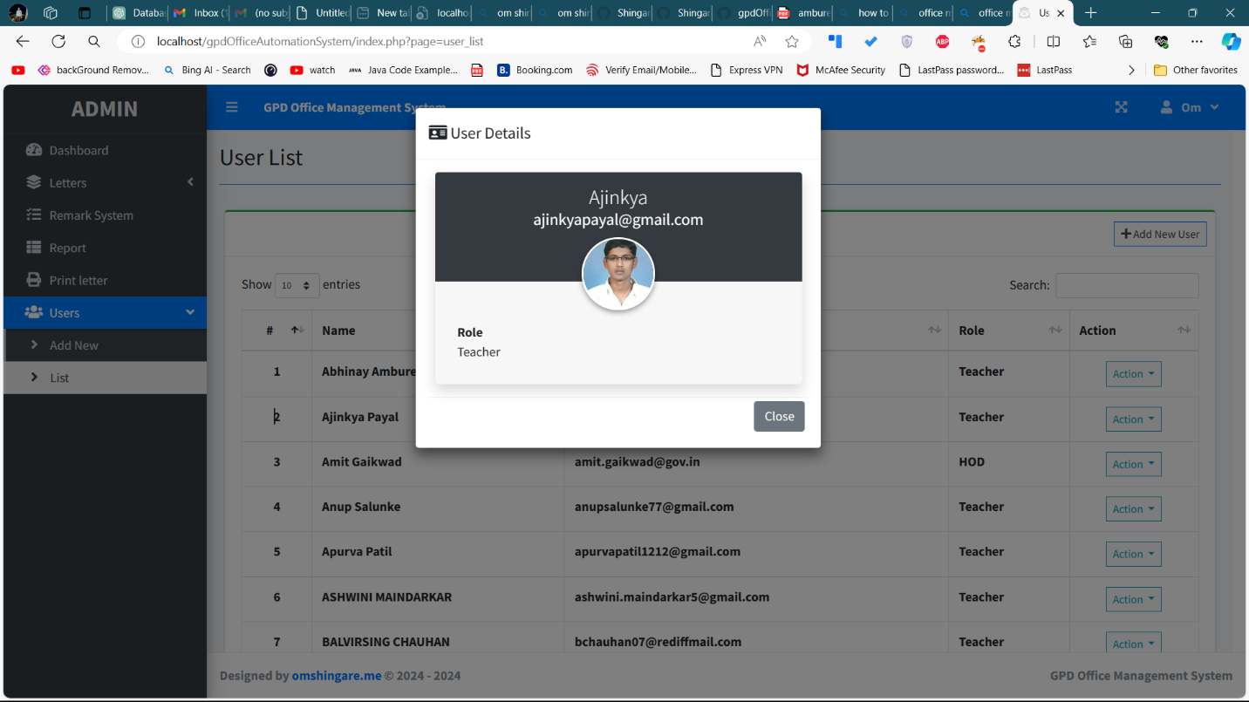

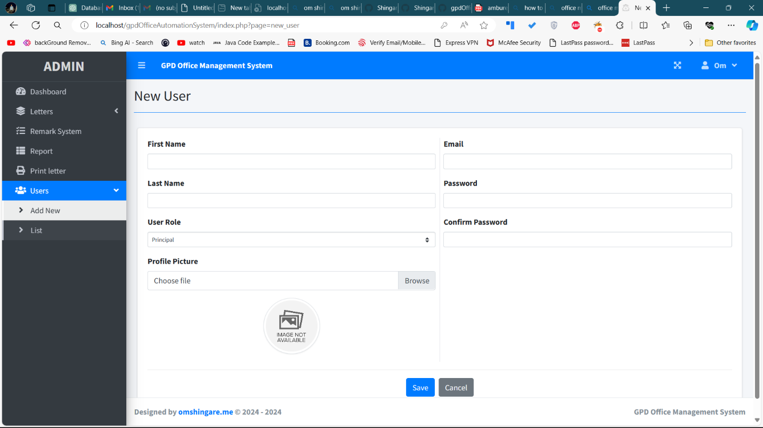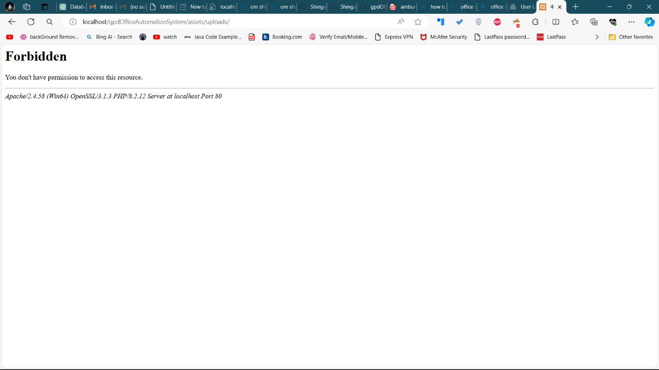

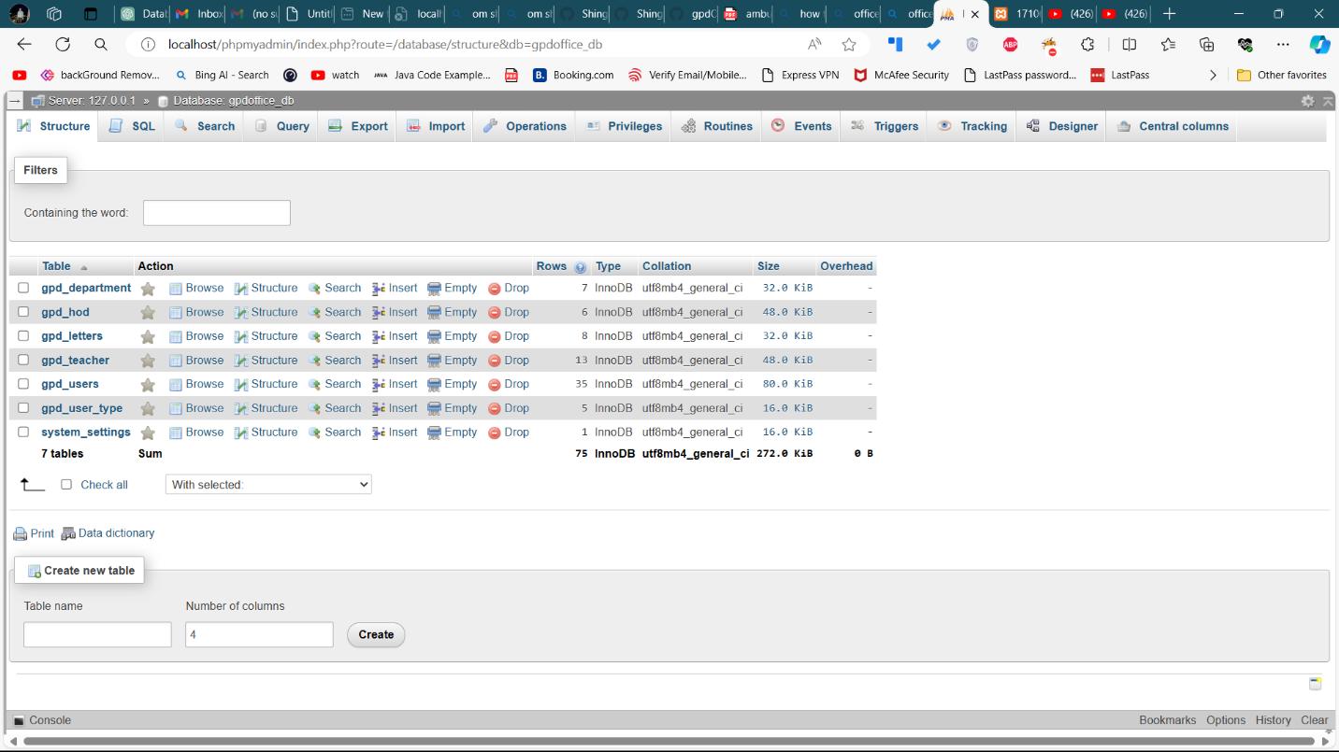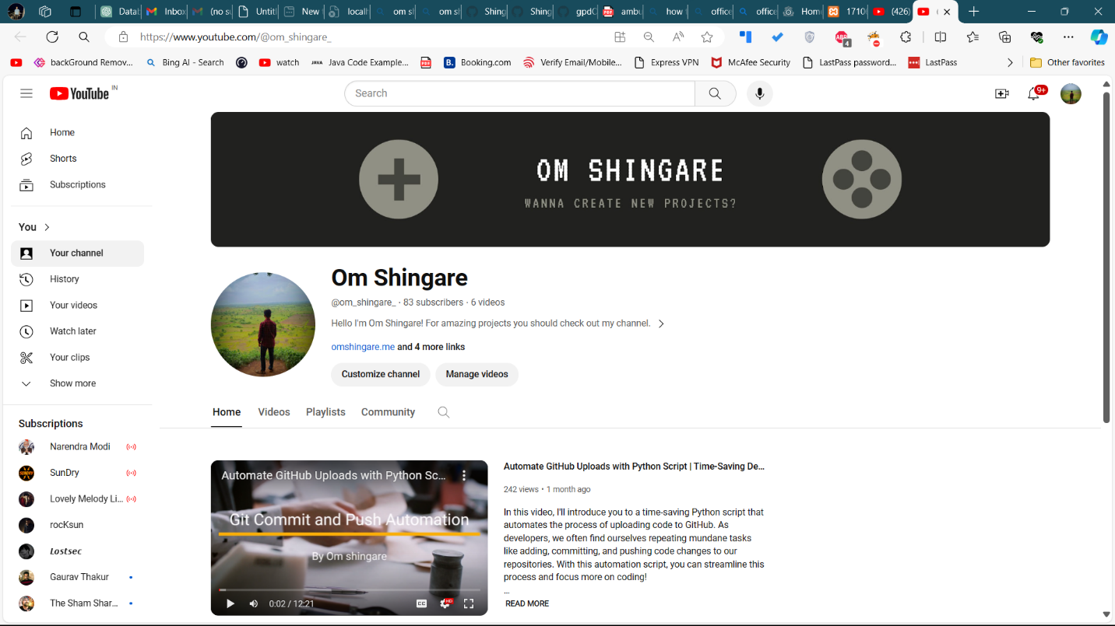

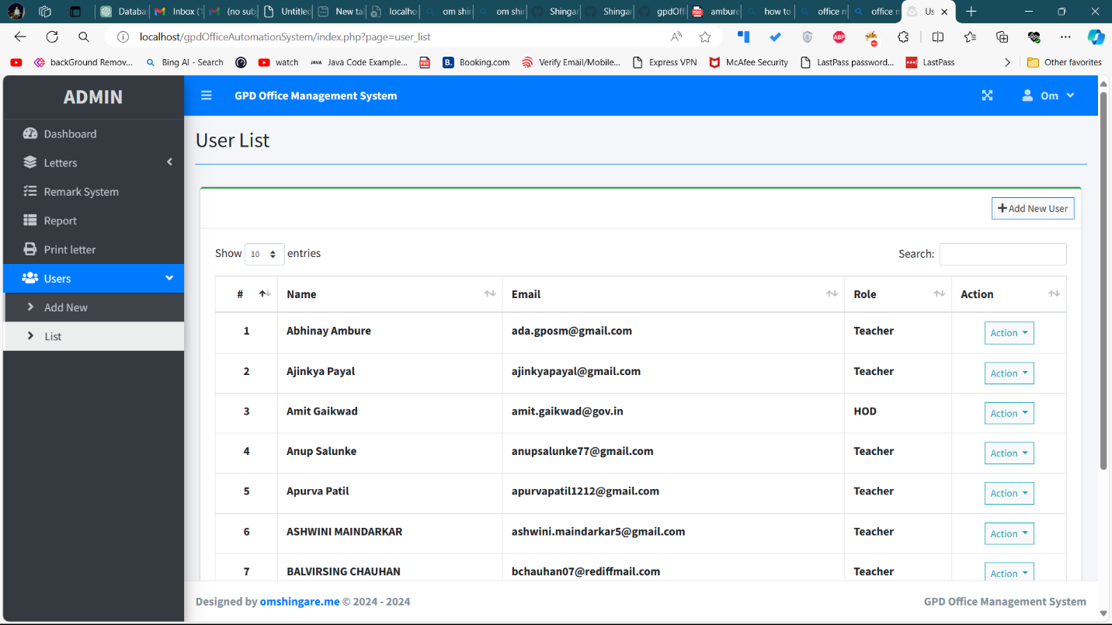

**APPLICATIONS**

**Letter Management:** The Office Automation System (OAS) will streamline the process of managing letters by providing a centralized platform for creating, printing, and tracking letters. This will eliminate manual administrative tasks and ensure efficient handling of correspondence.

**Document Requests Facilitation:** The OAS will facilitate document requests by allowing users to submit requests electronically. This centralized system will track the status of document requests, streamline approval processes, and provide timely responses to users.

**Feedback Mechanisms:** The OAS will include feedback mechanisms to gather input from stakeholders on various aspects of college operations. This feedback will enable administrators to identify areas for improvement and address concerns in a timely manner, enhancing transparency and accountability.

**Information Dissemination:** The OAS will enable seamless dissemination of information to stakeholders through announcements, notifications, and alerts. This will ensure timely communication of important updates, events, and announcements, fostering better engagement and collaboration within the college community.

**Streamlined Administrative Tasks:** The OAS will automate manual administrative tasks such as letter creation, printing, and tracking. This will save time and resources for college staff, allowing them to focus on more strategic initiatives.

Overall, the OAS will serve as a comprehensive solution to address operational inefficiencies and communication gaps at Government Polytechnic College, Dharashiv. By centralizing administrative tasks, facilitating document requests, collecting feedback, and enabling information dissemination, the OAS will enhance efficiency, transparency, and student engagement within the institution.

**CHAPTER 7 CONCLUSION AND FUTURE SCOPE**

**CONCLUSION**

In conclusion, the implementation of the Office Automation System (OAS) at Government Polytechnic College, Dharashiv, represents a significant step towards addressing operational inefficiencies and communication gaps resulting from manual administrative tasks and outdated communication methods. Recognizing the need for a centralized system to manage various administrative functions such as letter creation, printing, tracking, document requests, feedback mechanisms, and information dissemination, the OAS was conceptualized to provide an integrated solution aligned with the institution's objectives of efficiency, transparency, and student engagement.

The decision to conceptualize and implement the Office Automation System (OAS) signifies a pivotal step towards resolving these longstanding issues. The OAS has been carefully designed to centralize administrative processes and streamline key functions such as letter management, document creation, printing, tracking, document requests facilitation, feedback mechanisms, and information dissemination.

By centralizing administrative processes and leveraging technology to streamline operations, the OAS will bring about several benefits. It will enhance efficiency by automating tasks, reducing turnaround times, and minimizing errors. The system will also promote transparency and accountability through real-time tracking of tasks and feedback mechanisms, ensuring stakeholders are informed and engaged. Moreover, the seamless dissemination of information will foster better communication and collaboration within the college community.

Moving forward, the successful implementation and utilization of the OAS will require ongoing commitment, collaboration, and adaptation. Continuous monitoring, feedback collection, and system refinement will be essential to address evolving needs and maximize the system's effectiveness. Ultimately, the OAS represents a transformative tool for Government Polytechnic College, Dharashiv, empowering the institution to operate more efficiently, transparently, and in alignment with its mission to enhance student engagement and success.

**FUTURE SCOPE**

The Office Automation System (OAS) you've developed for your college has the potential for future enhancements and expansions. Here are some possible future scope areas for your project:

**Integration with Additional Systems:** The OAS can be integrated with other systems used by the college, such as the student information system, library management system, and financial management system. This integration will enable seamless data exchange between systems, further streamlining processes and enhancing data accuracy.

**Expansion of Functionality:** Over time, the functionality of the OAS can be expanded to include additional features and modules based on evolving needs. For example, the system can incorporate modules for academic scheduling, student attendance tracking and online assessment.

**Mobile Accessibility:** As mobile technology becomes increasingly prevalent, there is a growing demand for mobile accessibility in educational institutions. The future scope of the OAS may involve developing mobile applications or responsive web interfaces to allow users to access key functionalities on their smartphones or tablets.

**Enhanced Collaboration Tools:** Collaboration tools within the OAS, such as discussion forums, group messaging, and project management tools, can be further enhanced to facilitate collaboration among faculty, staff, and students. These tools can promote knowledge sharing, teamwork, and innovation within the college community.

**REFERENCE**

**Article**

Title: "[**What Is A Process Flow? Your Simple Guide | monday.com Blog**](https://monday.com/blog/project-management/process-flow/)"

Authors: John Smith, Mary Johnson

Published in: *Education Technology Journal*

https://monday.com/blog/project-management/process-flow/

**Blogs**

Title: *Bootstrap*

https://docs.bootstrap.com/

**In Person**

|  |  |
| --- | --- |
| **Designation** | **Name** |
| Teacher | Prof. Bhagyashri Mane |
| Teacher | Prof. Amit Gaikwad |
| Teacher | Prof. Satish Pore |

**Online Resource:**

Website: *EduTech Insights*

Description: A platform providing insights and articles on educational technology and administrative solutions.

**DEDICATION**

Creating our Office Automation System has been a big step in making things easier for everyone in our college. Before, tracking letters was a hassle because it had to be done manually. But now, with our new website, teachers and department heads can easily keep an eye on where their letters are in the approval process.

Our system has made everything clearer and more accountable. Teachers don't have to worry about their letters getting lost or forgotten anymore. And because everything is online, it's much easier for everyone to see what's happening with each letter.

By solving these problems, our project has not only made things smoother but also freed up time for teachers and department heads to focus on more important tasks. Our Office Automation System has brought positive changes to our college, and it's set us up for even better things in the future.

In the end, our system isn't just about technology; it's about making our college run better and helping everyone work together more easily. We're excited to keep improving our system and making our college even better in the years to come.



Scan Here

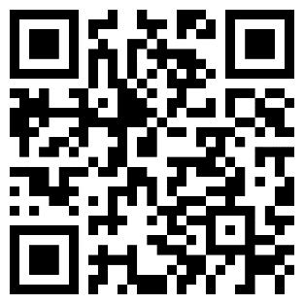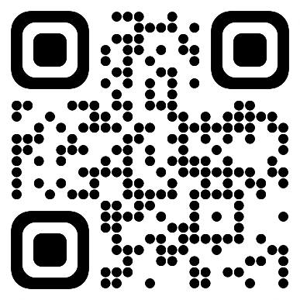

Top of Form